Project Report

Title:Temperature Controller using thermoelectric module

Supervised by: Prof. Amit Verma

Electrical Engineering Dept.

I.I.T. Kanpur

Submitted By :

Akhilesh Chauhan

Roll No.- 170070

**Contents**

1. Introduction………………………………………………………………………...2
2. Thermoelectric Effect…………………………………………………………..2-4

2.1 Causing effects

2.2 Energy equilibrium of a thermoelectric cooler

1. Components Used……………………………………………………………….5-6

3.1 Thermoelectric Module

3.2 Temperature Sensor

3.3 H-bridge

3.4 LCD Display

3.5 Arduino

3.6 Heat Sink and Cooling fan

3.7 5K potentiometer

4. Circuit Flow Diagram…………………………………………………………….7-8

5. Actual Circuit………………………………………………………………………...9-10

6. Results…………………………………………………………………………………...11

7. Limitations……………………………………………………………………………..11

8. Future Scope..……………………………………………………………………..….11

9. Appendix……………………………………………………………………………11-12

10. References…………………………………………………………………………….13

Introduction

The aim of the project is to create a desired temperature using a thermoelectric module and implement a negative feedback loop to accurately adjust the temperature to the desired one.

Thermoelectric Effect

The thermoelectric effect is the conversion of temperature differences to electric voltage/current and electric voltage/current to temperature differences. A thermoelectric device creates voltage when there is temperature difference applied to both sides. Conversely, it creates a temperature difference when a voltage is applied to it. They consist of arrays of differently doped semiconductors(n type and p type) which are physically parallel to each other but form a closed circuit. That is, they are thermally in parallel and electrically in series[1]. At an atomic scale, the charge carries diffuse from the hot side to the cold side due to the difference in the energies of carries lying in these regions. So, the net flow of charge is from the hot side to the cold side.

The thermoelectric effect encompasses three separately identified effects: the **Seedback effect**, **Peltier effect**, and **Thomson effect**[2]. These three effects combined with thermodynamics can explain the thermoelectric effect and give the equations to work with thermoelectrics.

Peltier Effect : The phenomenon of absorption (or dissipation) of heat by a

junction between two dissimilar materials when electrical current(I) flows through the junction. The heat qp absorbed/dissipated by the junction is:

qp = πI (1)

where π (V) is a temperature dependent Peltier coefficient corresponding to a specific pair of materials[1].

Seedback Effect : It is a process by which heating (or cooling) of the junction of two dissimilar materials generates an electrical potential of the junction:

π = αT (2)

where α (V/K) is a Seebeck coefficient[1].

Thomson Effect : In different materials, the Seebeck coefficient is not constant in temperature, and so a spatial gradient in temperature can result in a gradient in the Seebeck coefficient. This effect is called the Thomson effect.

τ = dα/dT (V/K2) (3)

τ is given as the Thomson coefficient. But this effect is quite small and often can be neglected[1].

Thermal Convection : This is a mode of heat transmission described by physical constant k (W/Km), which is determined by thermal conductivity and geometry of the pellet. Θ (K/W) is a thermal resistance of the couple

Θ = (1/k)* (h/A) (4)

T = Θq (5)

where h/A is geometry factor, h – height of the pellet (m), A –cross-section area (m2), T – temperature (K), and q – heat (W)[1].

Joule heating : It is the physical process of heat dissipation on the resistive elements. The electrical resistance R of a couple of pellets is:

R = ρ *(h/A) (6)

q = I2 R (7)

where ρ - resistivity of the material (Ω m), q – Joule heating(W), I – electric current (A).

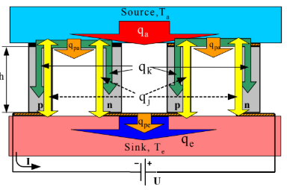

Fig1. Energy Equilibrium of a Thermoelectric cooler[1]

Following the first law of thermodynamics, one can express the energy equilibrium at both sides of the thermoelectric module that are defined as the absorbing (a) and emitting (e) junctions. For absorbing side, one can write:

qa = ∆T/Θm + αmTaI - I2Rm/2[1] (8)

And for the emitting side, one can write

qa = ∆T/Θm + αmTaI + I2Rm/2 (9)

αm = αN (10)

Rm = RN (11)

Θm = Θ / N (12)

where qa is a heat absorbing at a-side, qe – heat emitting at e-

side, N – number of couples, Ta and Te – temperatures of (a-) and (e-) sides in K, and ∆T=Te-Ta[1].

The electrical part of the module is described as electrical resistance Rm and an electrical potential difference U:

U = αmTe - αmTa = αm∆T[1] (13)

Components Used

1.Thermoelectric Module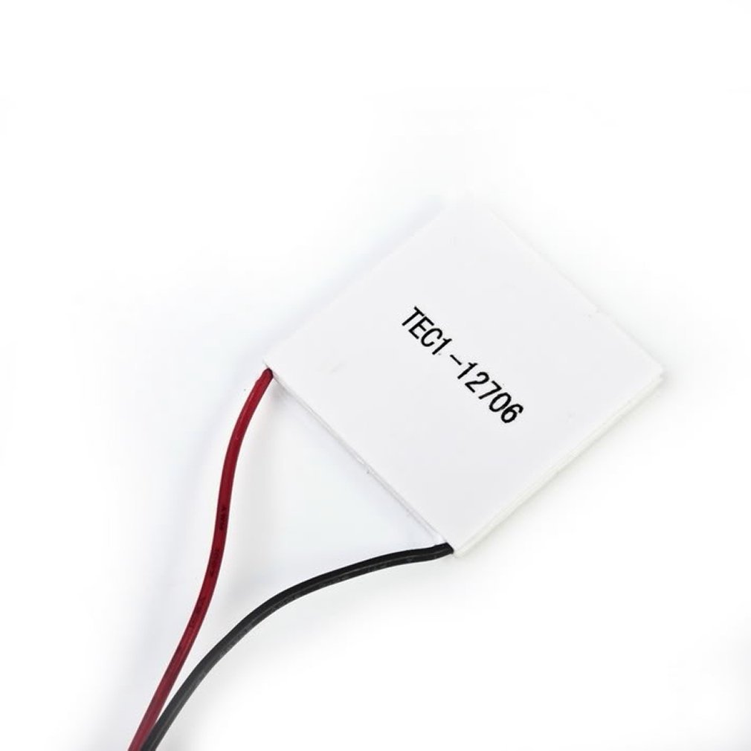

The thermoelectric module used is TEC1-12706. It is the device that causes the thermoelectric effect. It is a small module which is operable up to 138°C. The operating voltage is 12V and the maximum current and power dissipation are 6A and 92W respectively. They are widely used in industrial areas, for example, computer CPU, CCDs, portable refrigerators, medical instruments, and so on.

Fig2 : TEC1-12706 Module[3]

2. Temperature Sensor 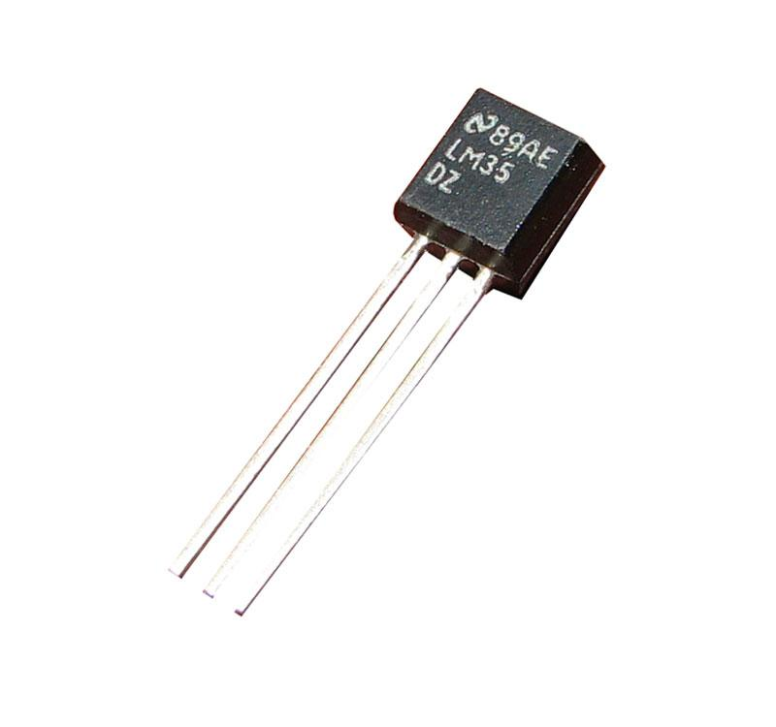

The temperature sensor used is LM35. The LM35 series are precision integrated-circuit temperature devices with an output voltage linearly-proportional to the Centigrade temperature. It can read temperatures between −55°C to 150°C[5]. Fig3: LM35 sensor[4]

3. H-Bridge

Fig4: L298 module[6]

The L298 H-bridge is a high voltage, high current dual full-bridge driver designed to accept standard TTL logic levels and drive inductive loads such as relays, solenoids, DC and stepping motors. It is used to control the power supplied to the module and also the direction of current through the module.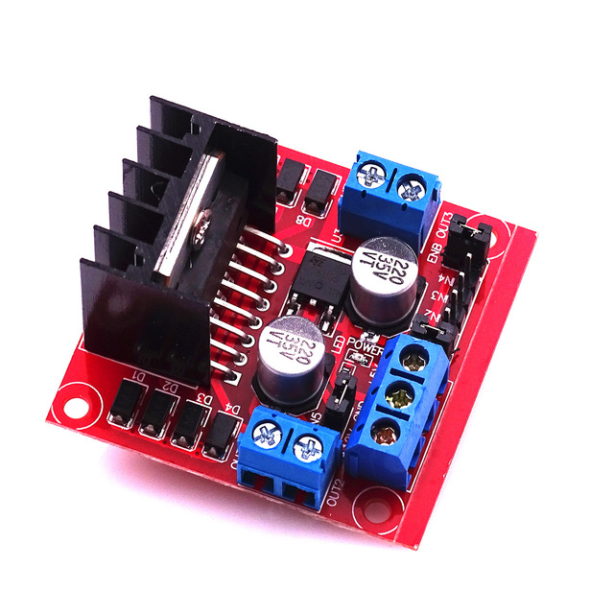

4. LCD Display

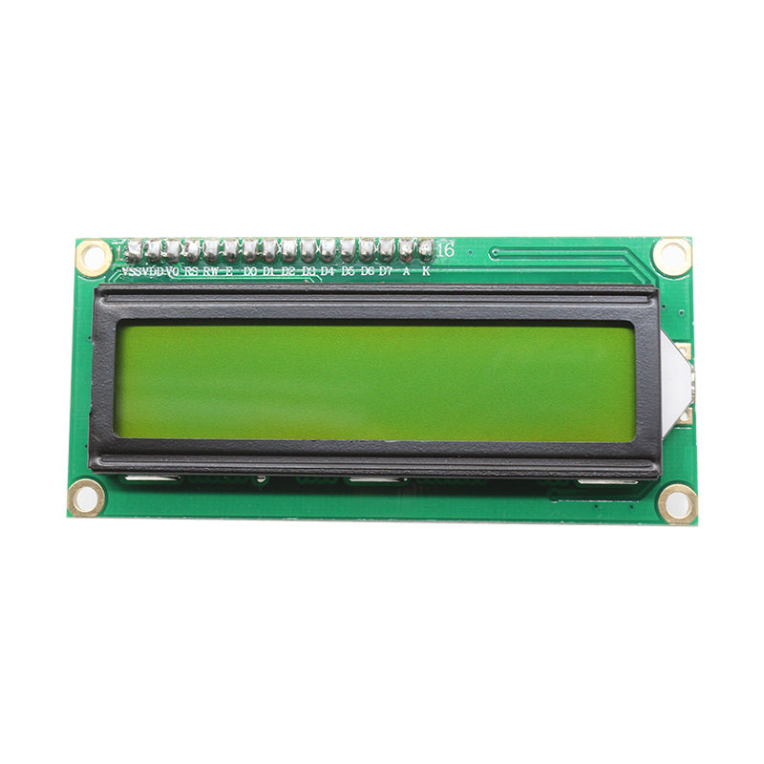

The display used is LCD 1602A. It is a 16x2 Character dot Matrix LCD Display Module. It uses a 5V power supply.

Fig5: 1602A LCD[7]

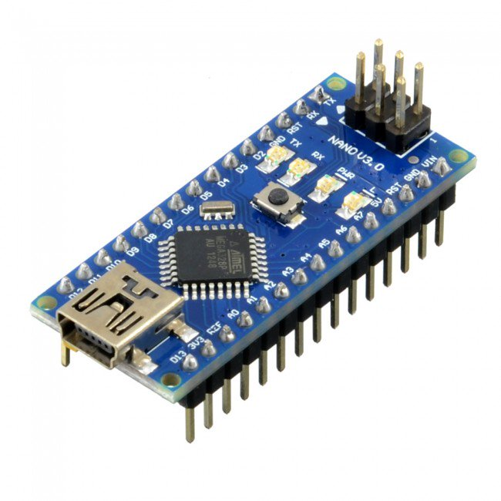

5. Arduino

The arduino being used is arduino nano. It serves as a communication with the LCD, the H bridge and the temperature sensor. The main reason for using nano is that it is easier to use on a GPP board.

Fig6: Arduino Nano[8]

6. Heat sink and cooling fan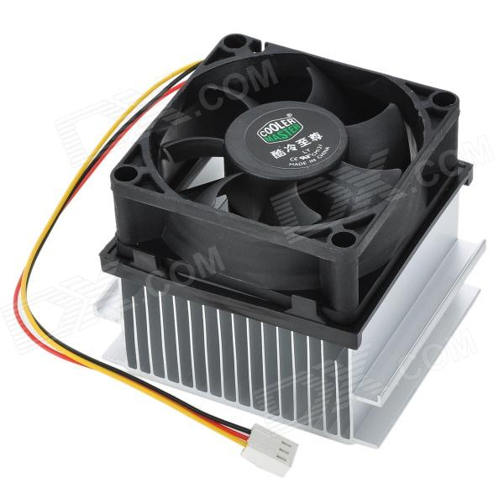

The heat sink and cooling fan are 40mm* 40mm, which is the same size as that of the module.

Fig7: Heat sink and cooling fan[9]

7. 5K potentiometer

The 5K potentiometer is used to change the value of the desired temperature. Fig8: 5k pot[10]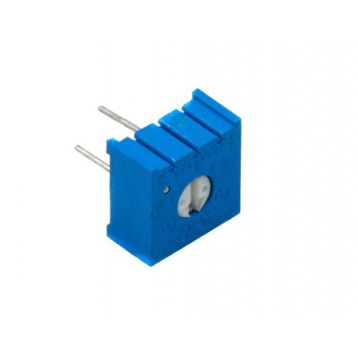

Circuit Flow Diagram

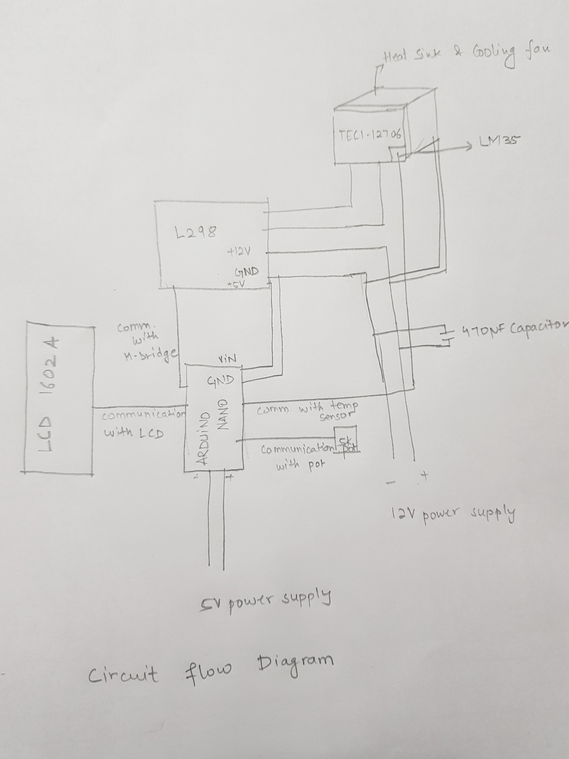

Fig9: Circuit Flow Diagram

The arduino is powered through a 5V power supply. It communicates with the 5k potentiometer to decide the value of the set temperature. It communicates with the temperature sensor to get the temperature of the thermoelectric module. It also communicates with the LCD to display the value of the set temperature and the temperature of the module. Depending upon the values of the set temperature and the module temperature, the arduino communicated with the H bridge to decide the direction of current flow and the duty cycle of the signal given to the thermoelectric module. The duty cycle is decided by the PID controller algorithm which outputs a value between 0-255, depending on the relative values of the two temperatures. As the temperature of the module approaches the desired temperature, the duty cycle of the PWM signal decreases. The frequency of the PWM signal is 980Hz. The L298 is powered by a 12V power supply, which in turn also powers the arduino via the +5V terminal through Vin. The +12 V supply also powers the cooling fan which draws a little current(50mA). The supply is connected to a 470 μF capacitor in parallel to reduce the load on the power supply as the H-bridge switches direction much frequently near the set temperature.

Fig 10,11 : Actual Circuit

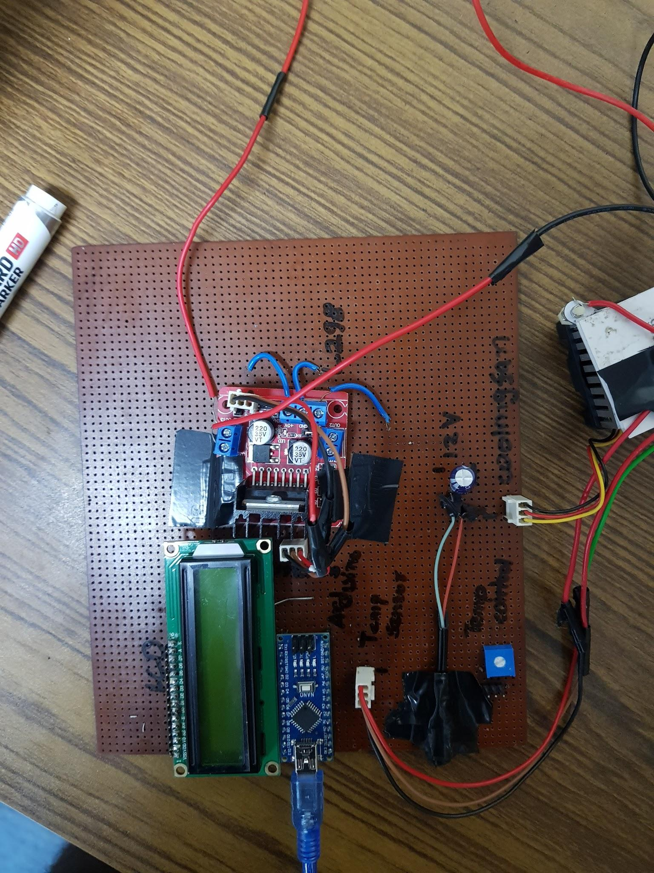

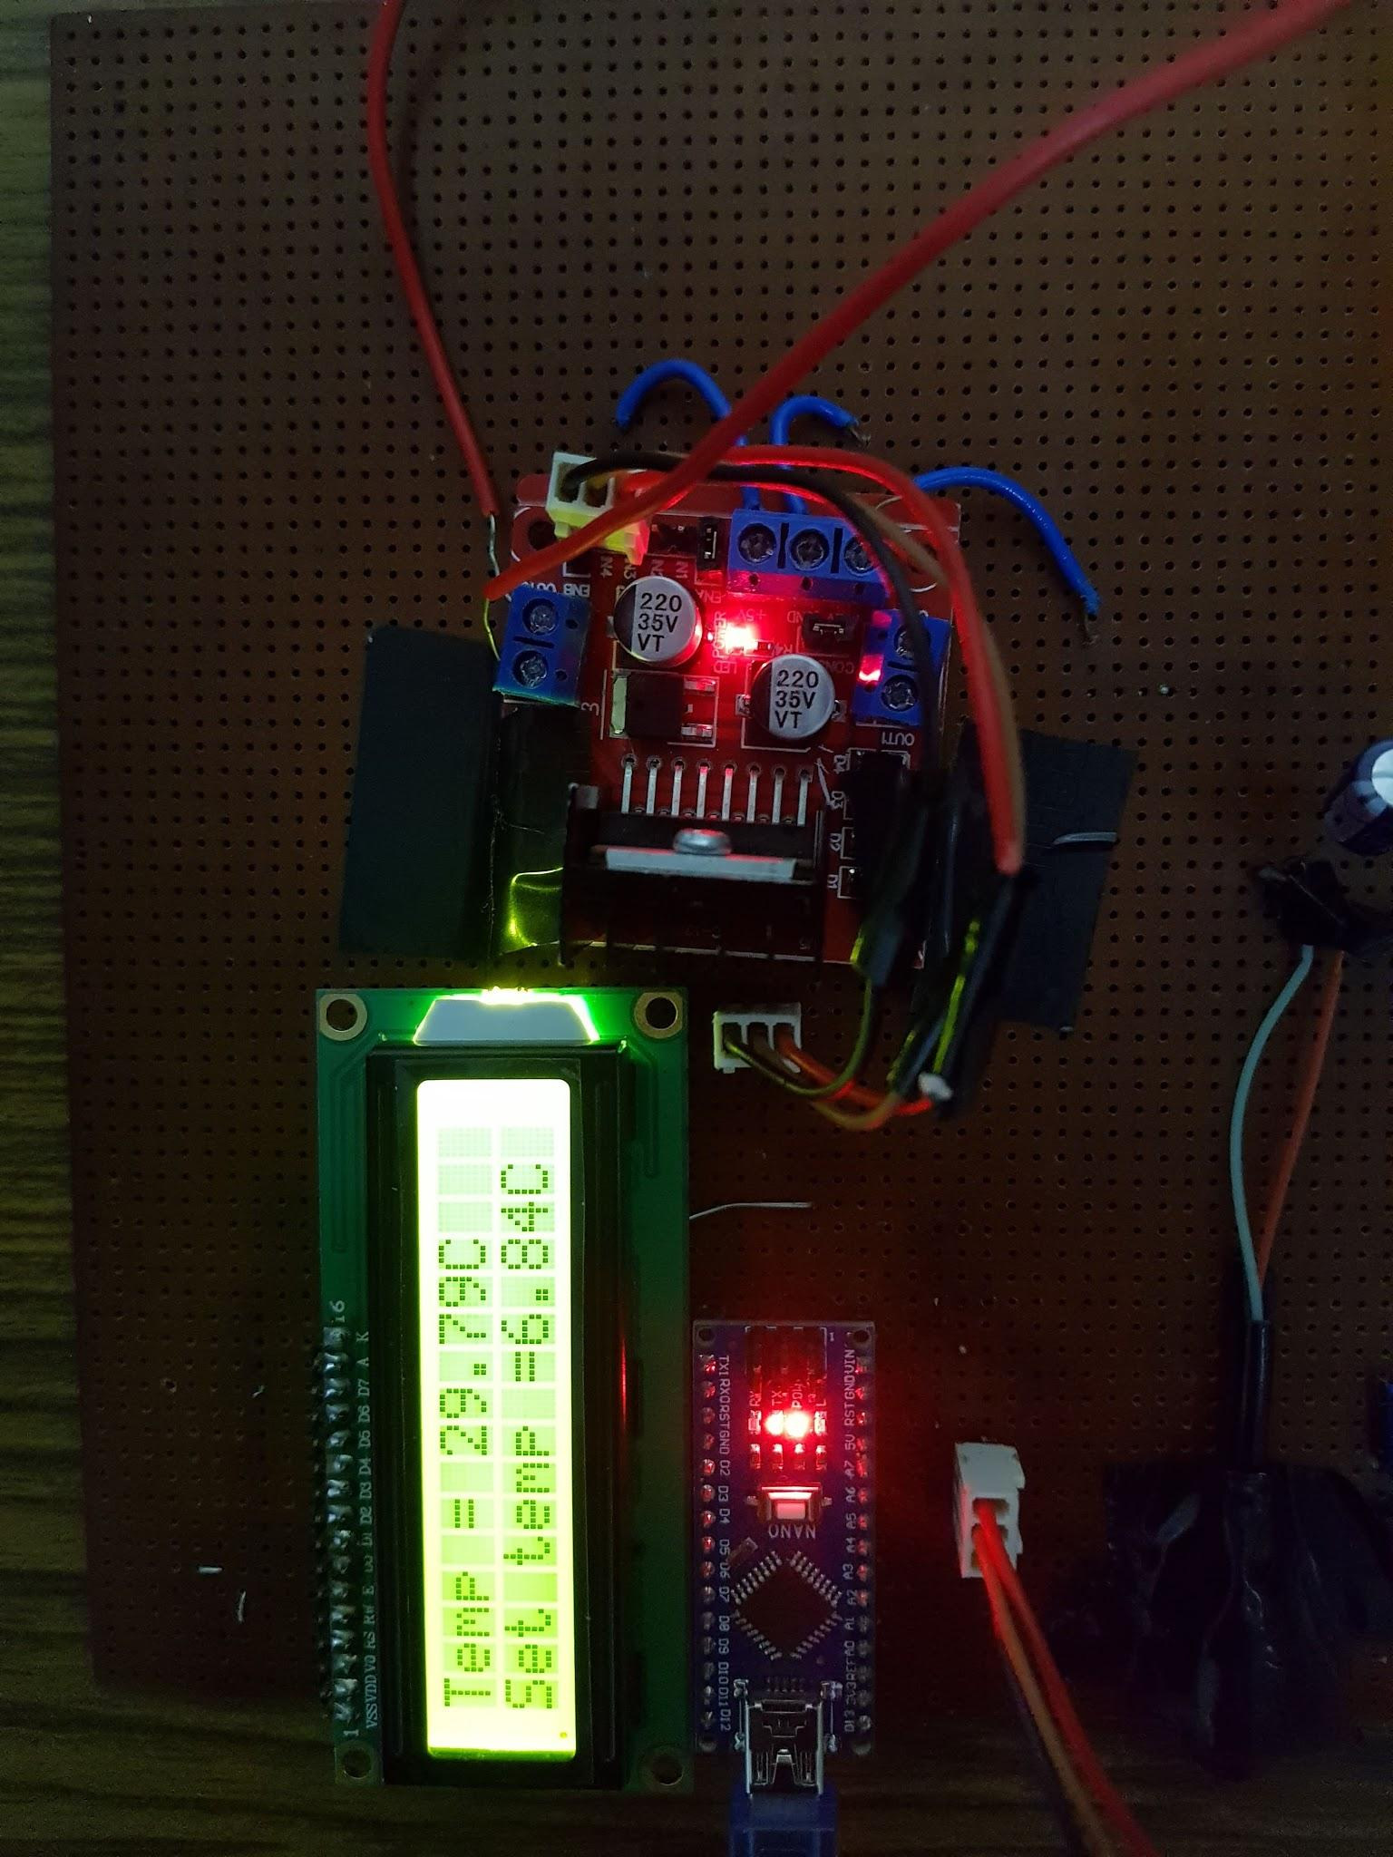

Results

* The maximum temperature achieved by the module = 70-71°C.
* The minimum temperature achieved by the module = 17-18°C.

Limitations

* The heat sink and the cooling fan are tiny and they are not able to extract much heat from the hot side.
* The power supply has a current limit of 2A, whereas the module can be operated up to 6A of current. Due to this, the module is not able to achieve more extreme temperature as the power supply is limited.

Future Scope

* The cooling system can be improved by using a bigger heat sink and cooling fan.
* The cooling fan can be kept above a hollow structure which will allow smooth flow of hot air thus increasing the cooling capacity.

Appendix

* Arduino code: <https://docs.google.com/document/d/1iuDcr-loGBpwib4RMJpZ6kSLq6vVZxiUB3z3c-jSrsE/edit?usp=sharing>
* Plots of temperature variations(deg C) as a function of time

Fig12: Temperature Variation when set temperature is below room temperature[11]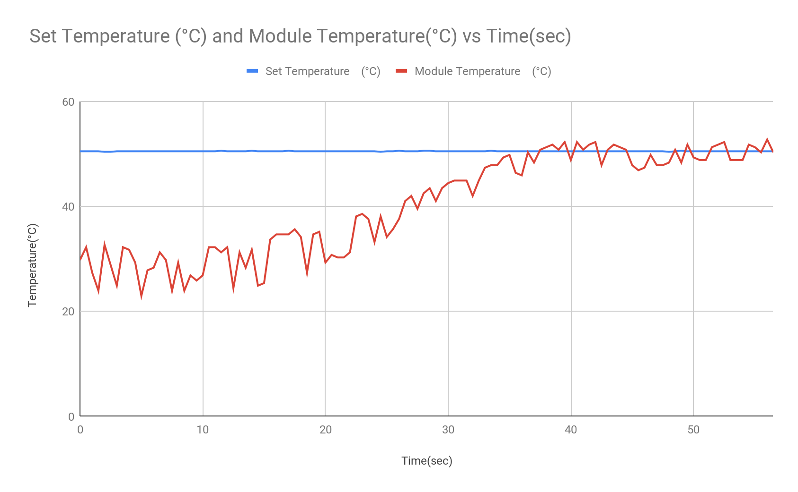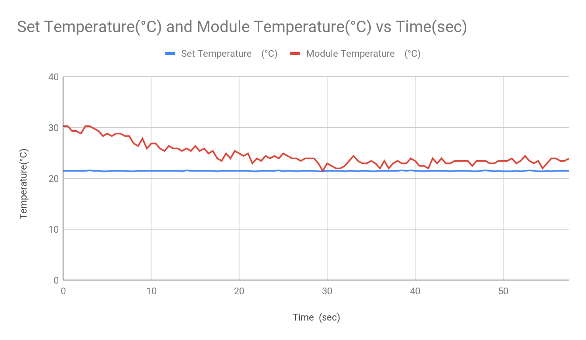

Fig13: Temperature Variation when set temperature is above room temperature[12]

References and Sources

[1]. Simon Lineykin and Sam Ben-Yaakov*, *“Modeling and Analysis of Thermoelectric Modules ”*

[2].<https://en.wikipedia.org/wiki/Thermoelectric_effect>

[3].<https://www.google.com/url?sa=i&source=images&cd=&ved=2ahUKEwj9qte-oMnjAhUHeisKHRhICYwQjRx6BAgBEAU&url=https%3A%2F%2Frobu.in%2Fproduct%2Ftec1-12706-thermoelectric-peltier-cooler-12-volt-92-watt%2F&psig=AOvVaw2V4Lw-2wSIoKyHp9JnXJOI&ust=1563909889982533>

[4].<https://www.makerlab-electronics.com/my_uploads/2017/03/LM35-Temperature-Sensor-01.jpg>

[5]. <http://www.ti.com/product/LM35>

[6].<https://ae01.alicdn.com/kf/HTB16dF.nx1YBuNjy1zcq6zNcXXaC/1PCS-L298N-motor-driver-board-module-L298-for-arduino-stepper-motor-smart-car-robot.jpg_640x640.jpg>

[7].<http://www.electrominds.com/images/products/secondary/lcd-1602-yellow-green-1.jpg>

[8].<https://core-electronics.com.au/media/catalog/product/cache/1/image/650x650/fe1bcd18654db18f328c2faaaf3c690a/d/e/device20_1000_1.jpg>

[9].<http://www.primelec.com/media/catalog/product/cache/1/image/9df78eab33525d08d6e5fb8d27136e95/6/4/644725-001-pic1.jpg>

[10].<https://5.imimg.com/data5/CB/KY/MY-8857053/potentiometer-trim-pots-500x500.jpg>

[11].<https://docs.google.com/spreadsheets/d/1k32vYbLBw3e0mMRtbIWHzQaMkWl5uotV6o3ruTCnE5k/edit?usp=sharing>

[12].<https://docs.google.com/spreadsheets/d/1d6vba9UfQmxWqzZAyU0GQrgQRuK6wsDEWc8cN-VYxJE/edit?usp=sharing>